**Facebook Data Analysis (Hive Assignment)**

**Q1**: Find out the total no of users in the dataset.

**Query**: select count (*) As Total_users

from default.pseudo_facebook;

**

**Q2**: Find out the no of users above the age of 25.

**Query:** SELECT count(*)

FROM default.pseudo_facebook

WHERE age > 25;

**Output**:

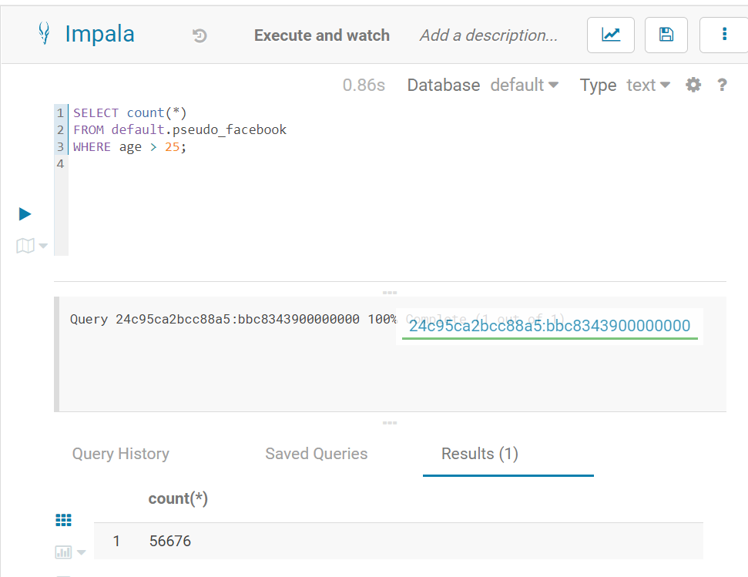

**Q3**: Do male face book users tend to have more friends or female users.

**Query:** SELECT gender, avg(friend_count) as avg_friends

FROM default.pseudo_facebook

GROUP BY gender;

**Output:**

**Q4**: How many likes do young people receive on facebook as opposed to old people.

**Query:** SELECT

CASE

WHEN age < 30 THEN 'Young'

WHEN age >= 30 AND age <= 50 THEN 'Middle-aged'

ELSE 'Old'

END AS age_group,

SUM(likes) AS total_likes

FROM default.pseudo_facebook

GROUP BY

CASE

WHEN age < 30 THEN 'Young'

WHEN age >= 30 AND age <= 50 THEN 'Middle-aged'

ELSE 'Old'

END;

**

**Q5**: Find out the count of facebook users for each birthday month.

**Query:** SELECT count (*) as NO_Of_Users

FROM default.pseudo_facebook

GROUP BY dob_month;

**Output**:

**Q6**: Do young members use mobile phones or computers for facebook browsing.

**Query**: SELECT

CASE

WHEN age < 30 THEN 'Young'

ELSE 'Not Young'

END AS age_group,

sum(mobile_likes) as total_mobile_Users,

sum(www_likes) as total_computer_Users

FROM default.pseudo_facebook

WHERE age <30

GROUP BY

CASE

WHEN age < 30 THEN 'Young'

ELSE 'Not Young'

END;

**Output**:

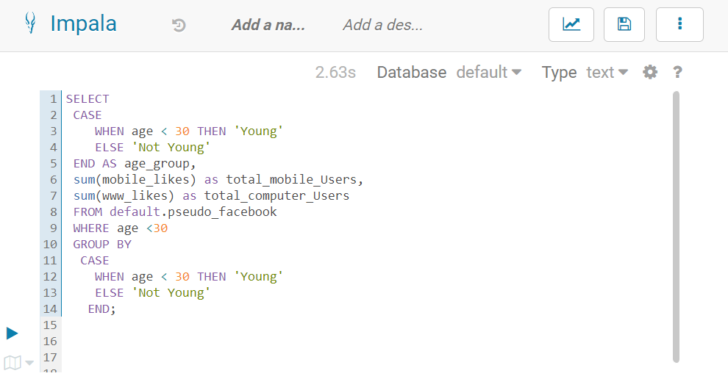

**Q7**: Do adult members use mobile phones or computers for facebook browsing.

**Query**: SELECT

CASE

WHEN age BETWEEN 18 and 30 THEN 'Adult'

ELSE 'Not Adult'

END AS age_group,

sum(mobile_likes) as total_mobile_Users,

sum(www_likes) as total_computer_Users

FROM default.pseudo_facebook

WHERE age BETWEEN 18 and 30

GROUP BY

CASE

WHEN age BETWEEN 18 and 30 THEN 'Adult'

ELSE 'Not Adult'

END;

**Output:** 

